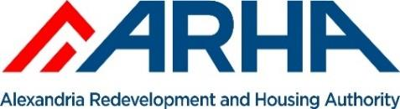

Request for Qualifications

Development Partner for
Alexandria Redevelopment
and Housing Authority
Solicitation # RFQ Q-20-01

Issue Date:
February 25, 2020
Acceptance Date:
2:00 p.m. April 17, 2020

Keith Pettigrew
Chief Executive Officer

Daniel Bauman
Board of Commissioners Chair

Solicitation and Attachment can be found:
https://ha.internationaleprocurement.com
Respondents shall provide one (1) original and five (5) copies of their Statement of Qualifications (“SOQ”) to include the information described in this Part and in the order as outlined below. Submit using three ring binders on 8.5 x 11 paper. Include only one (1) copy of the financial statements in a separate envelope marked Financial - Confidential. Include one (1) flash drive of the entire submission in electronic file format (please note financial statements should not be included on the flash drive). These items should be delivered by April 17, 2020, 3:00 p.m. in a sealed package clearly marked “Development Partner Qualifications for ARHA”

